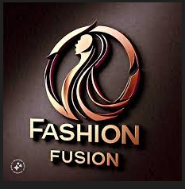

***Company Report of Fashion Fusion: Where Style Meets Innovation.***

***Md. Maydul Islam***

***Batch: 041***

***Department of Public Administration***

***08-12-202***

Table of Contents

1 Executive Summary of Fashion Fushion Company: 2

1.1 Company Overview 2

1.2 Key Features of Fashion Fusion 2

2 Products and Services 3

2.1 Product Line: 3

2.2 Services: 3

3 Marketing and Sales Strategy 3

3.1 Market Analysis 4

3.2 Operations Plan 4

4 Business Plan: 5

5 Sales and cost statistics: 6

5.1 Yearly sales Report 2024 : 6

5.2 Total sales in area based:2024 7

6 Challenges and Opportunities 8

6.1 Challenges: 8

6.2 Opportunities: 8

7 Conclusion 8

# Executive Summary of Fashion Fushion Company:

Fashion Fusion is a leading company in the fashion industry, known for its innovative approach to design and a strong commitment to sustainability. The brand seamlessly integrates traditional craftsmanship with contemporary trends to create products that resonate with a global, environmentally conscious audience.

## Company Overview

* **Vision:** To be the leading fashion brand, celebrated for innovation, quality, and customer satisfaction.
* **Mission:** To provide high-quality, stylish apparel that empowers individuals to express their unique personalities.
* **Values:** Creativity, Quality, Integrity, Sustainability, and Customer Focus.

## Key Features of Fashion Fusion

* **Sustainability:** Incorporates organic and recycled materials into its designs. Implements eco-friendly production processes to reduce waste and carbon emissions. Promotes fair trade and ethical sourcing throughout its supply chain.
* **Innovation:** Utilizes cutting-edge technology in design and production, including 3D modeling and customizable products. Merges cultural heritage with modern fashion to create unique collections.
* **Collaborations:** Regularly partners with emerging designers and renowned artists for exclusive collections. Works with organizations that advocate for inclusivity and environmental conservation.

# Products and Services

## Product Line:

* + Women's wear (dresses, tops, bottoms, outerwear)
  + Men's wear (shirts, pants, suits, accessories)
  + Accessories (bags, jewelry, footwear)
* Example products with link = [Products](https://www.bing.com/images/search?q=products+of+fashion+fusion+company&qpvt=products+of+fashion+fusion+company&form=IGRE&first=1)

## Services:

* + Online shopping platform
  + In-store shopping experience
  + Personal styling services
  + Alteration and tailoring services

Example products with link = [Products](https://www.bing.com/images/search?q=products+of+fashion+fusion+company&qpvt=products+of+fashion+fusion+company&form=IGRE&first=1)

# Marketing and Sales Strategy

* **Branding:** Develop a strong brand identity focused on elegance, innovation, and sustainability.
* **Digital Marketing:** Utilize social media, email marketing, and influencer partnerships to reach the target audience.
* **Retail Stores:** Establish a network of strategically located retail stores to provide an immersive shopping experience.
* **E-commerce:** Develop a user-friendly online store with seamless checkout and secure payment options.
* **Public Relations:** Build strong relationships with media outlets and fashion influencers to generate positive publicity.

## Market Analysis

* **Target Market:** Fashion-conscious individuals, including:
  + Young professionals seeking stylish workwear
  + Fashion enthusiasts who embrace the latest trends
  + Discerning consumers who value timeless elegance
* **Market Trends:**
  + Growing demand for sustainable and ethical fashion
  + Rise of online shopping and e-commerce
  + Increasing preference for personalized and customized products

## Operations Plan

* **Supply Chain Management:** Partner with reliable suppliers and manufacturers to ensure timely delivery and quality control.
* **Inventory Management:** Implement efficient inventory management systems to minimize stockouts and excess inventory.
* **Logistics:** Utilize efficient logistics and distribution channels to deliver products to customers on time.
* **Quality Control:** Maintain strict quality control standards throughout the production process.

# Business Plan:

**(1.)**

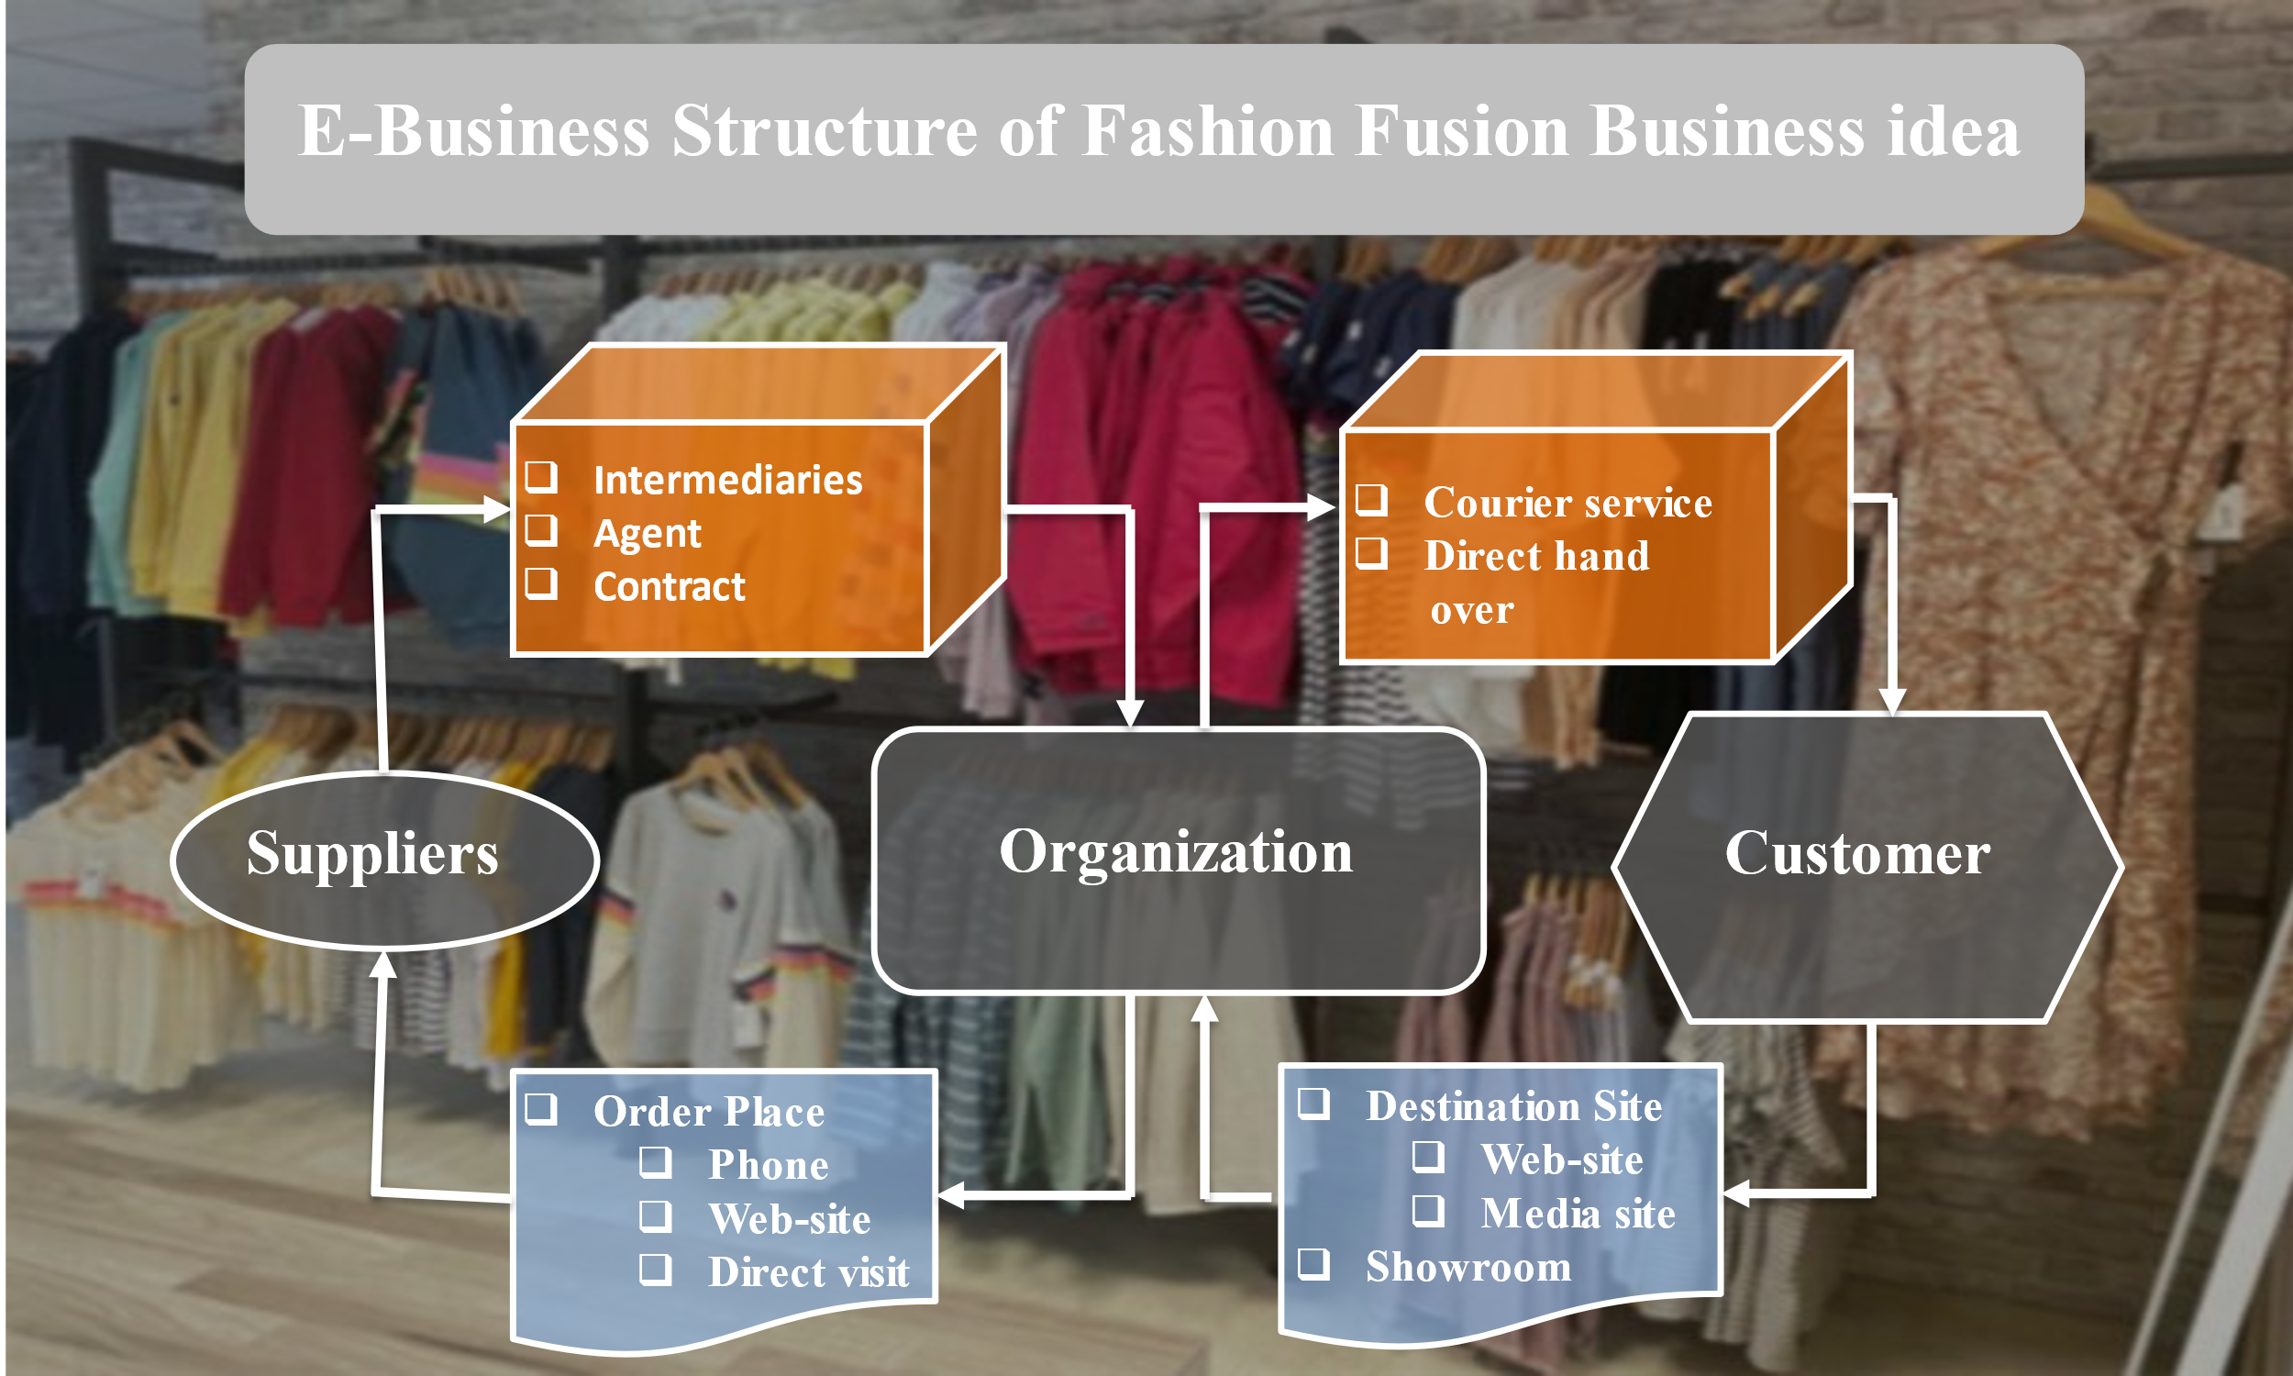

(2).

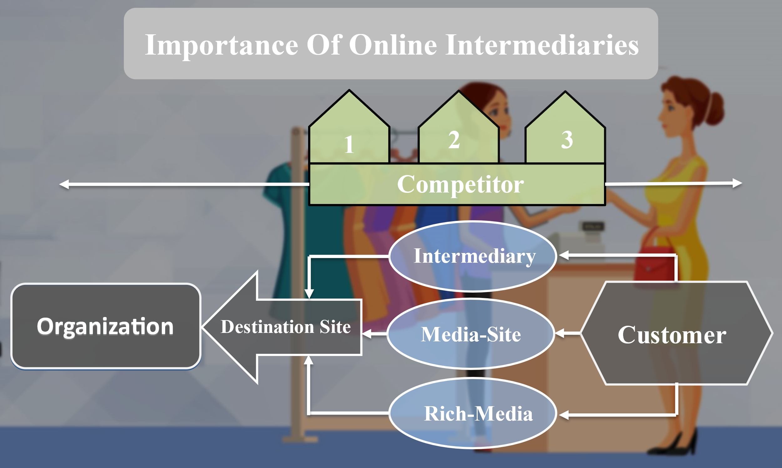

# Sales and cost statistics:

## Yearly sales Report 2024 :

|  |  |  |  |
| --- | --- | --- | --- |
| **Row Labels** | **Sum of Expenses** | **Sum of Sales** | **Sum of Profit** |
| January | 9288500 | 8750000 | -538500 |
| February | 9744300 | 9920000 | 175700 |
| March | 8904700 | 10000000 | 1095300 |
| April | 7345200 | 7957400 | 612200 |
| May | 8987000 | 9876500 | 889500 |
| June | 5215400 | 5164500 | -50900 |
| July | 9976500 | 11543600 | 1567100 |
| August | 7976700 | 8087900 | 111200 |
| September | 9879000 | 9969800 | 90800 |
| October | 6234800 | 7024000 | 789200 |
| November | 4534800 | 4809300 | 274500 |
| December | 8348700 | 8834800 | 486100 |
| **Grand Total** | **96435600** | **101937800** | **5502200** |

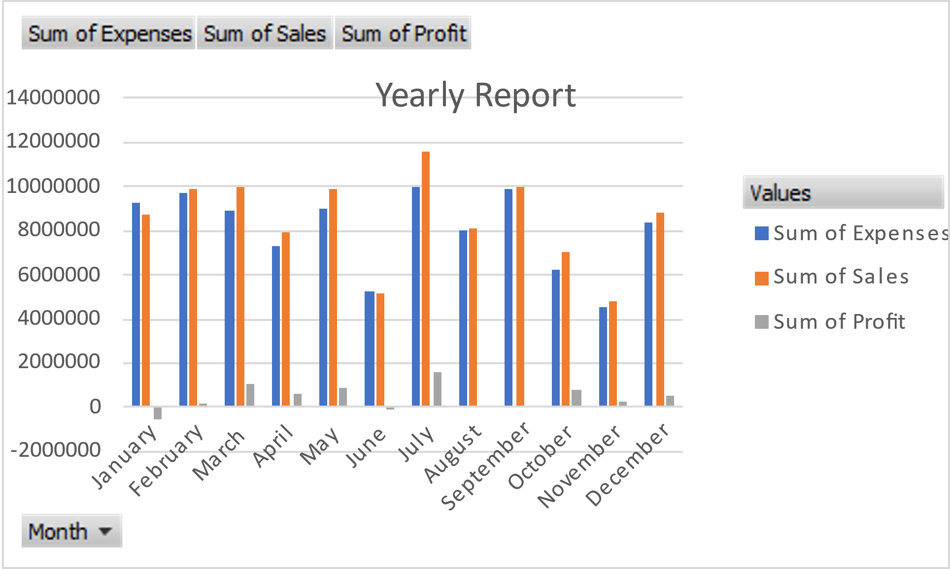

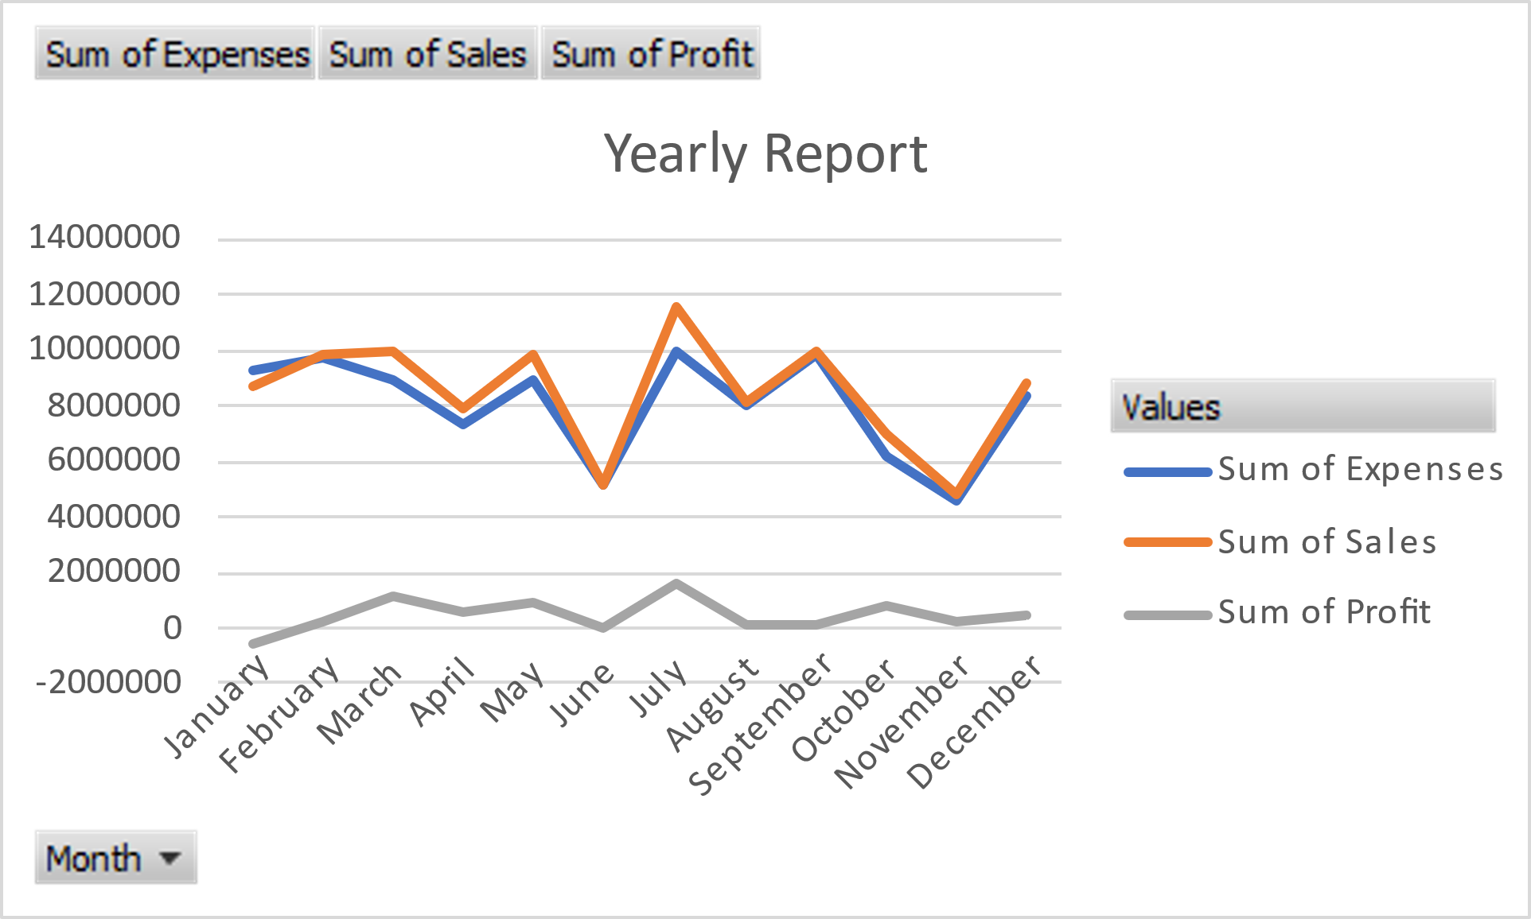

## Total sales in area based:2024

|  |  |
| --- | --- |
| **Row Labels** | **Sum of Total Sales (BDT)** |
| Barishal | 5010000 |
| Chittagong | 4340000 |
| Dhaka | 5850000 |
| Khulna | 4110000 |
| Rajshahi | 4760000 |
| Sylhet | 4600000 |
| **Grand Total** | **28670000** |

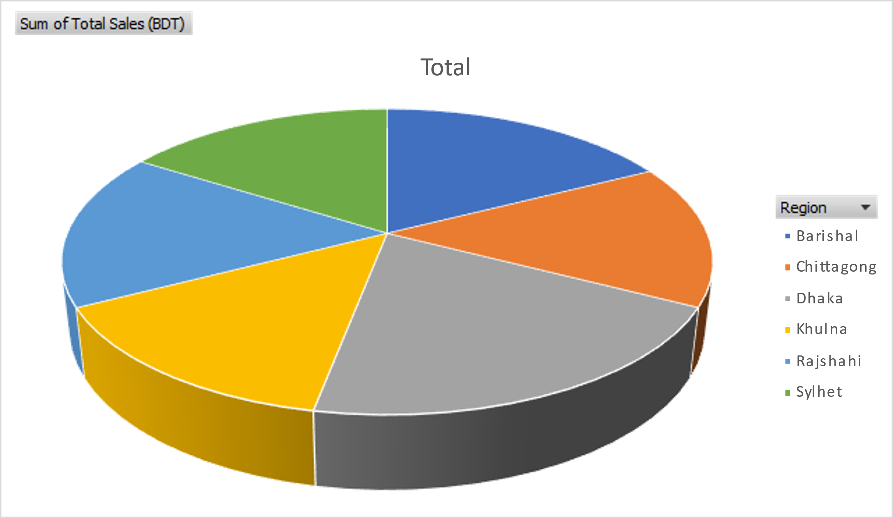

# Challenges and Opportunities

## Challenges:

* Navigating the competitive nature of the fashion industry.
* Balancing costs while maintaining sustainable and ethical production.

## Opportunities:

* Growing consumer demand for sustainable and customizable fashion.
* Expanding to untapped markets through digital platforms and collaborations.

# Conclusion

Fashion Fusion stands as a role model in the fashion industry by blending tradition, sustainability, and modernity. The company’s commitment to ethical practices and innovation ensures its position as a forward-thinking brand, catering to the needs of a global audience. By fostering collaborations, engaging with communities, and embracing technology, Fashion Fusion continues to shape the future of sustainable fashion.